Baseline task

The purpose of this task is to assess your knowledge of the Grade 9 work and basic algebra. Answer the following questions at the back of your 2 quire homework book.

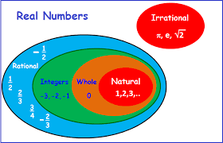

- Describe each of the following sets of numbers: $IN$, ${IN}_{0} and$ $Z$

- Make a copy of the number line below:

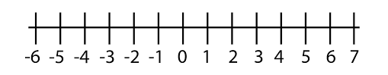
- Mark the positions of the following numbers on your number line. Use your calculator to help you.
-$\sqrt{8}$ ; $-2\frac{1}{4}; -1,5;$ $\frac{1}{3} ;$ 0,6 ; $\sqrt{2}$ ; $2,\dot{6}$; $π$
b. How accurately were you able to mark the positions of the numbers, -$\sqrt{8}$ ; $2,\dot{6}$ and
$π$ on the number line?
- Solve each of the following equations:

3.1.1 $3x-15=0$ 3.1.2 $x^{2}=36$

3.1.3 $x^{3}=-81$ 3.1.4 $\frac{6}{x}=2$
4. State whether each of the above solution belongs to$N$, $N_{0}$ , $Z$ or none of the three sets
of numbers.

